# Week 1

## Introduction to Formal Methods

* A formal method is a systematic, mathematically based approach to determine whether a program has specific desirable properties.

Software development life cycle🡺

Requirement analysis 🡺 System specification 🡺 Design 🡺 prototyping & implementation 🡺 verification, testing & integration 🡺 maintenance & enhancement

## Paper round abstract machine

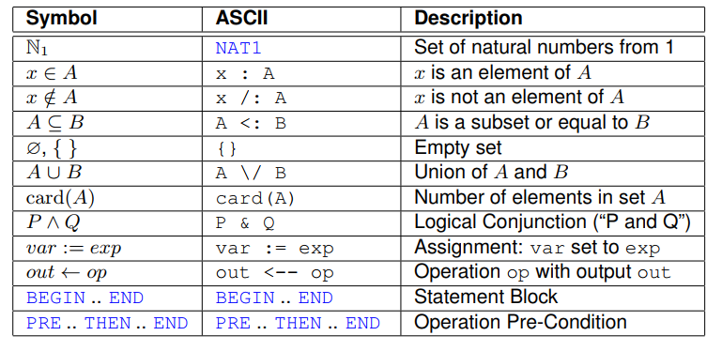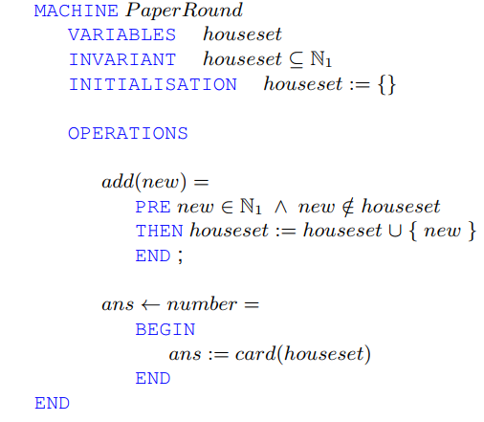

# Week 2

## Set

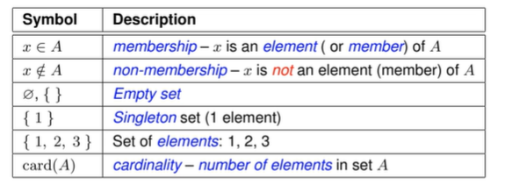🡺 collection of well-defined (same kind) objects (elements or members)

Integers 🡺 (….,-3,-2,-1,0,1,2,3,…)

Natural numbers 🡺 

Power set 🡺 (set containing all subsets of X)

x..y 🡺 range of numbers from x up to y inclusive

### SET Relations

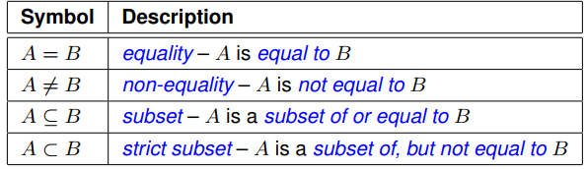

Construction of sets 🡺 given condition must hold all the members in the set

General form 🡺

 E.g.:

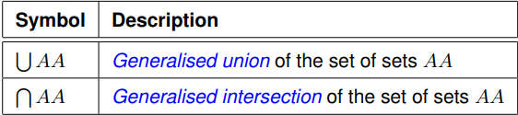Generalised versions 🡺

## Abstract Machine

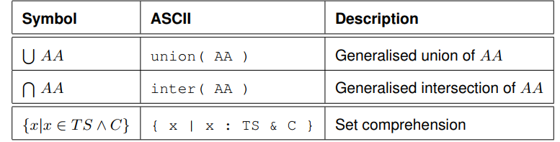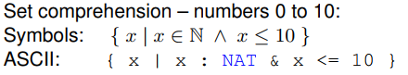

* Abstract machine
* state variables of the system and their types
* state invariants 🡺 properties that variables must satisfy
* Operations 🡺 transform and update the variables

**Sets** are used to achieve formalisation & abstraction

* 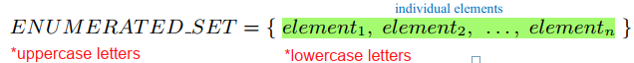Enumerated 🡺 defined sets
* Deferred 🡺 incomplete and definition delayed
  + 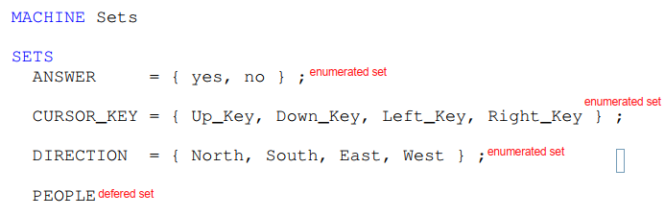High degree of abstraction

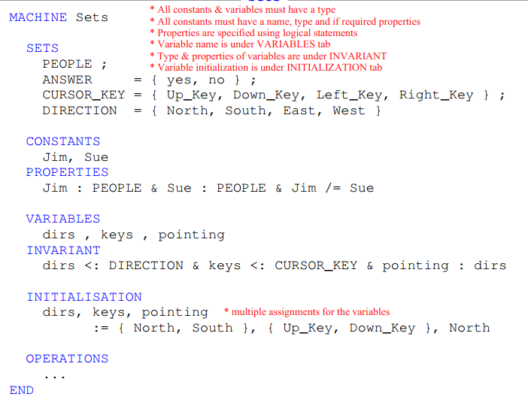

# Week 3

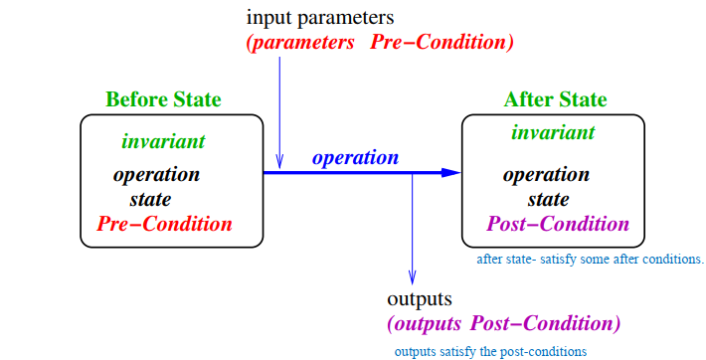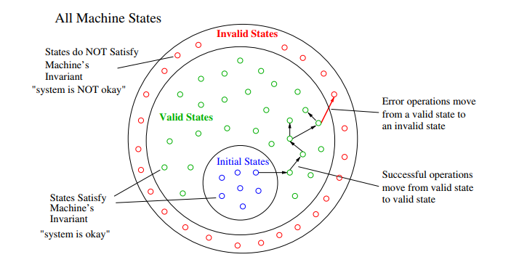

B model is a high-level, abstract modification specification that provides what the system should be like and how it should behave rather than how it should be implemented.

## Abstract machine structure

# Week 4: logic

## Propositional Logic

A proposition is a logical expression which is true or false.

Law of Excluded Middle 🡺 Whenever a proposition is true the opposite proposition of it is false 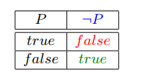



Preposition symbol :

* P \/ Q is true if and only if P is true or Q is true
* P/\ Q is true if and only if P ad Q are both true
* P 🡺 Q is true if and only if Q is true and P is false (P & Q doesn’t need to be connected in any way)
* P ⬄ Q is true if and only if P 🡺Q & Q🡺P are true
* (P) is true if and only if P is true
* **Not 🡪 And 🡪 OR 🡪 Implication 🡪 Equivalence**
* -

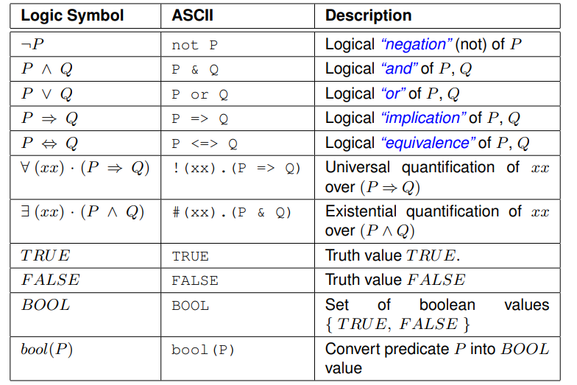

# Week 6

## Relations

Relations 🡺 To relate the elements of one set to the elements of another set.

Cartesian Product 🡪 can be used to combine any number of sets.

Binary Relations 🡪 A particular case of a Cartesian product is an ordered pair. A binary relation is a set of ordered pairs, of related values.

Ordered pair and maplet🡪 x |-> y = (x,y) 🡪 meaning of x maps to y

Projections🡪

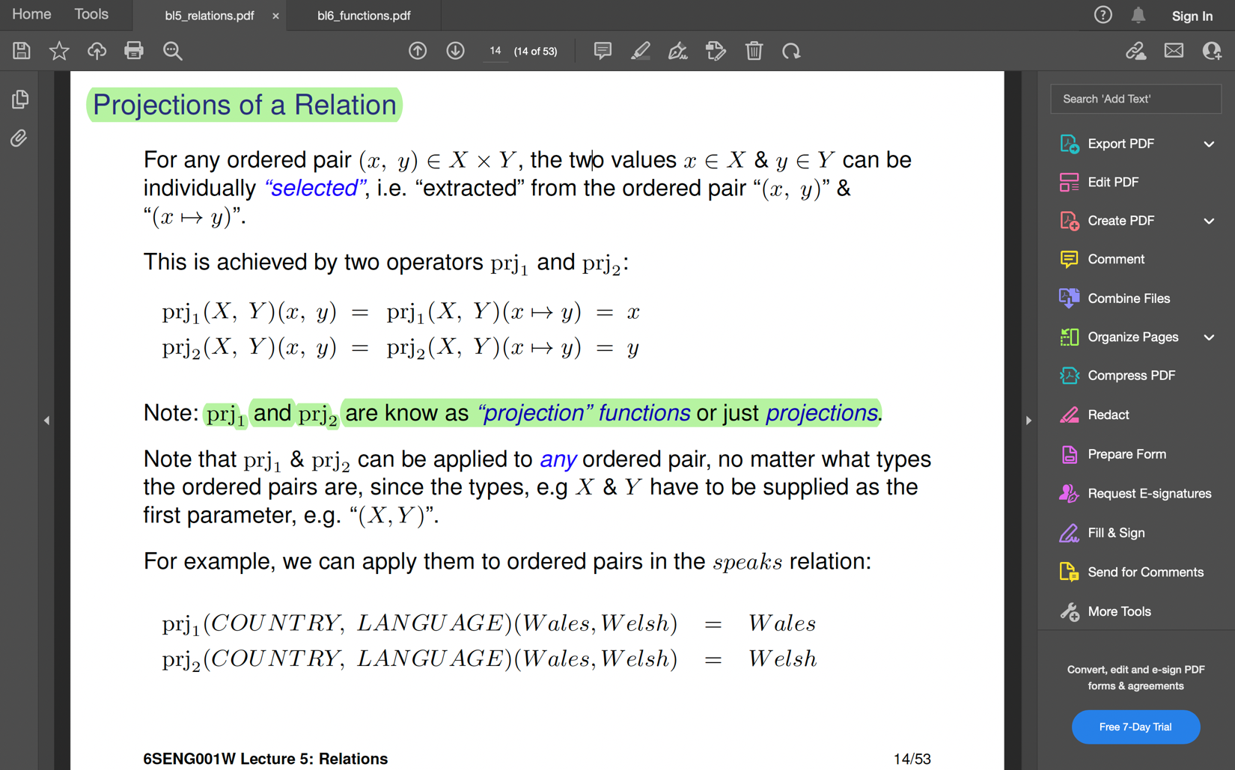

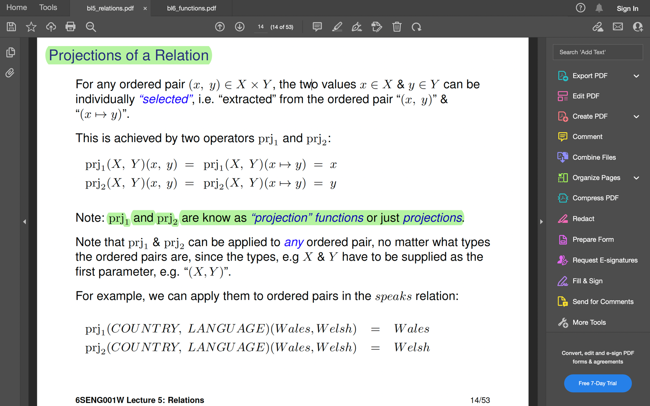

Membership 🡺 To see if a relation relates to a pair of values.

Domain (elements of the source) and Range (elements of the target)

Relational Image 🡪 What languages are spoken in Canada & Wales?

speaks [ {Canada, Wales}] = {French, English, Welsh}

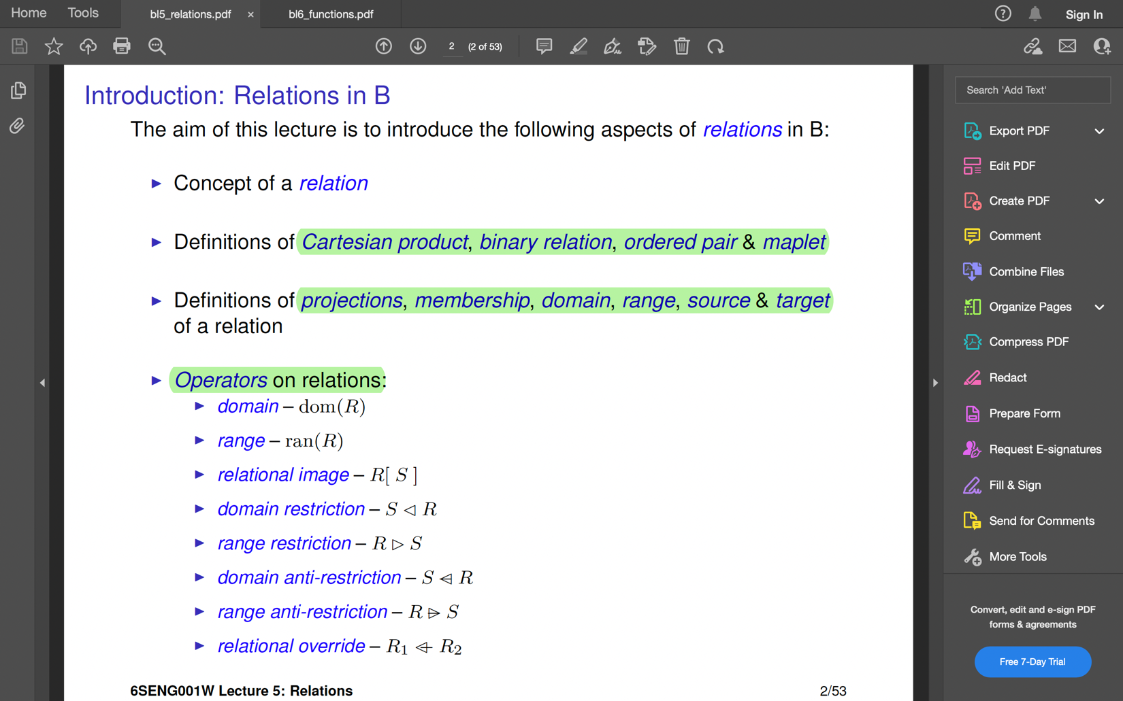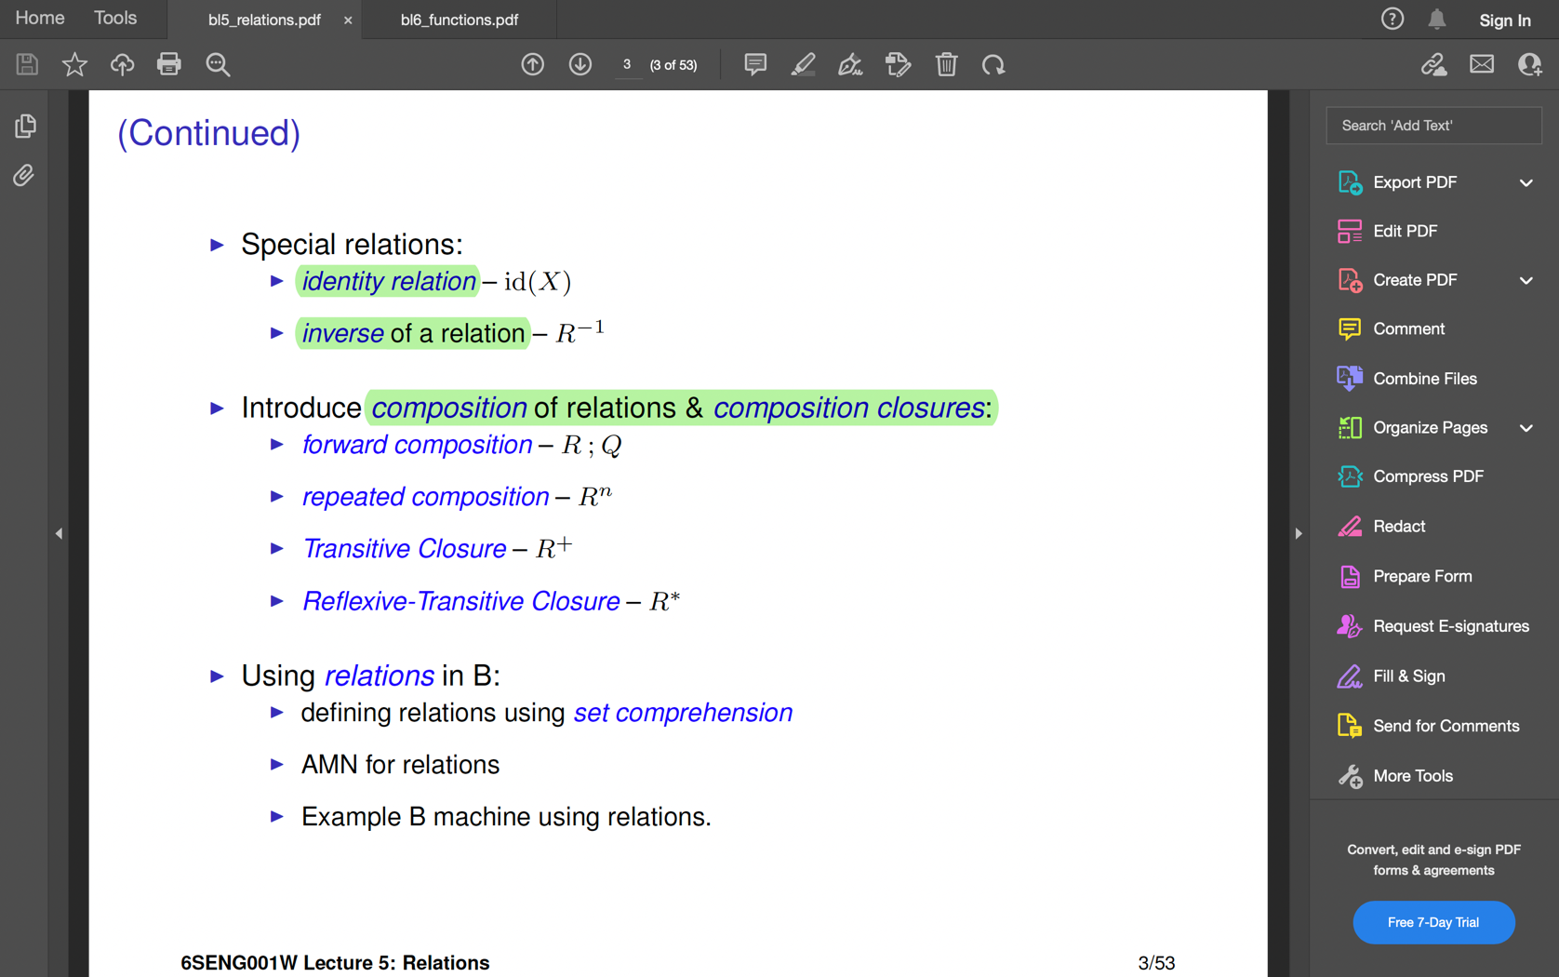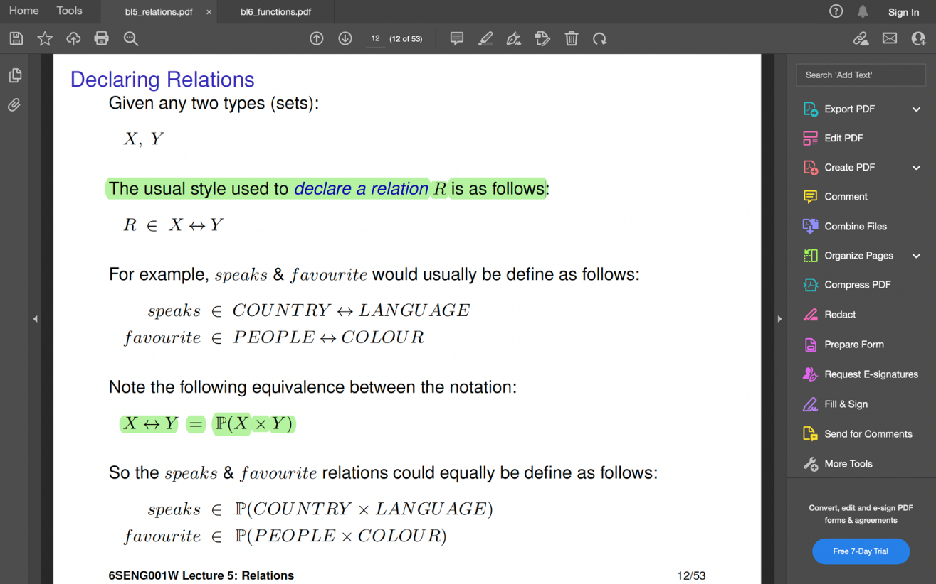

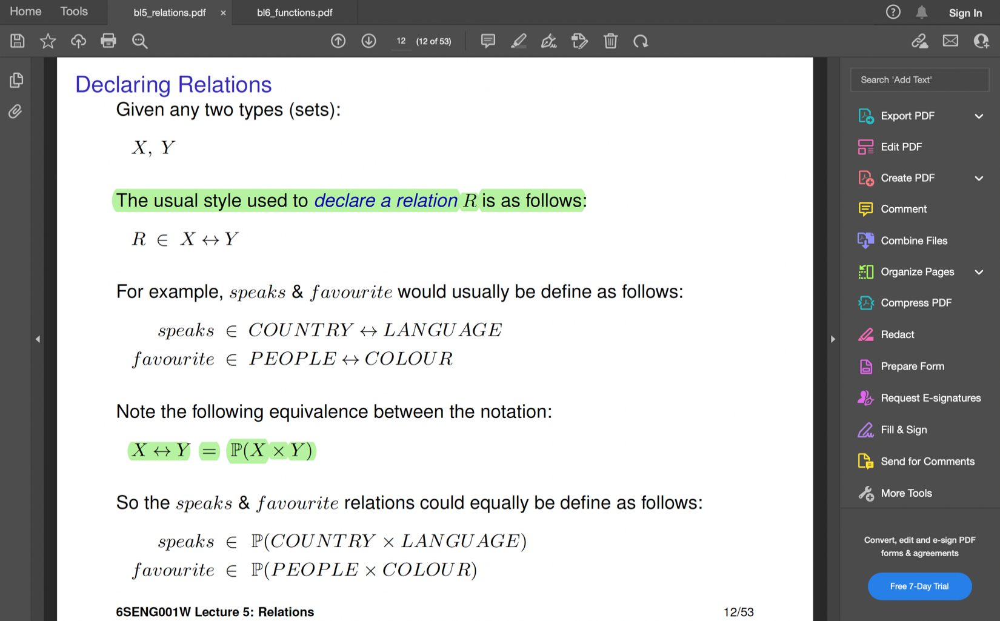

**Domain Restriction** 🡪 Used to create a new relation by **restricting** a relation to that part where the **domain** is contained in a set.

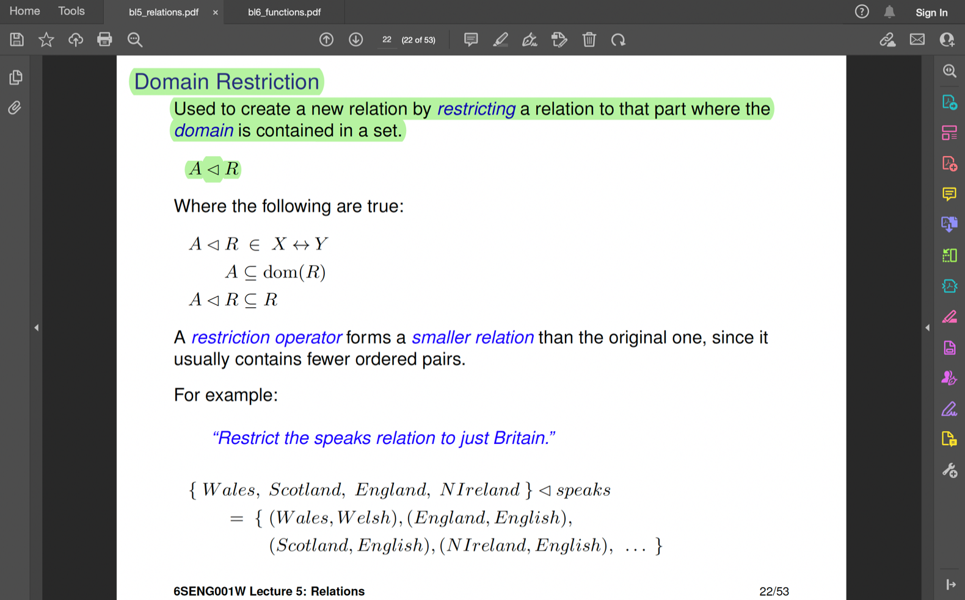

**Range Restriction** 🡪 This is used to restrict a relation R to that part where the **range** is contained in a set B.

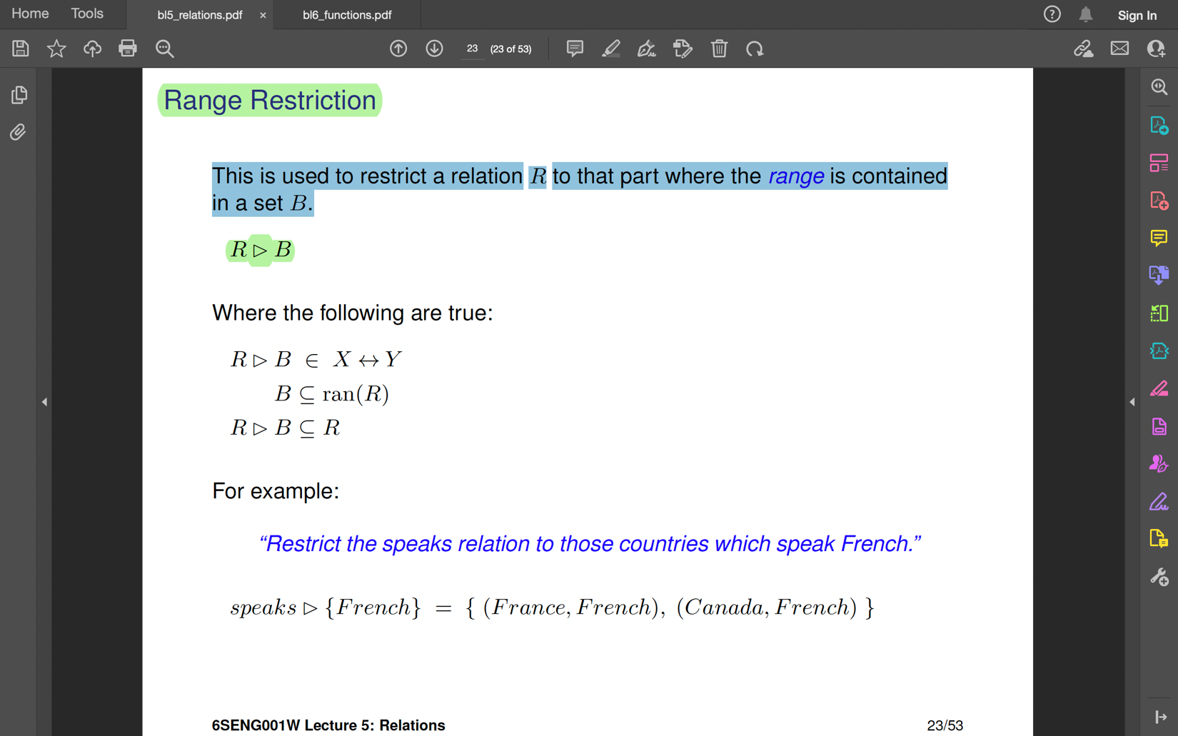

**Domain Anti- Restrictions** 🡪 also known as domain subtraction. This is used to restrict a relation to that part **where the domain is not contained** in a set.

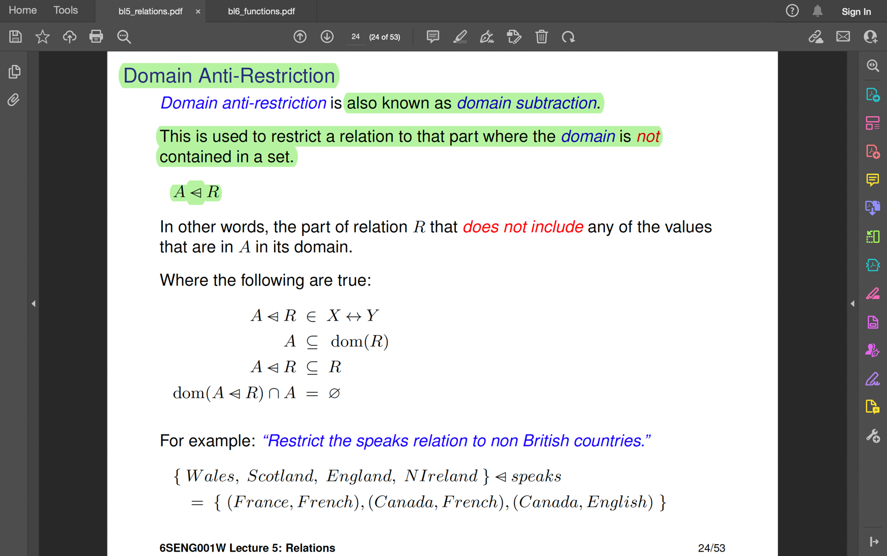

**Range Anti-Restrictions**🡪 Used to restrict a relation to that part where the **range is not contained** in a set.

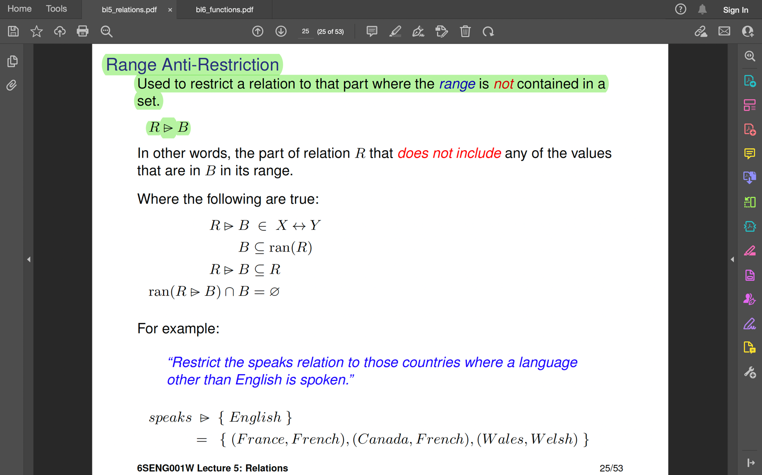

**Relational Override Operator** 🡪 A relation can be modified by adding pairs, removing pairs or by altering.

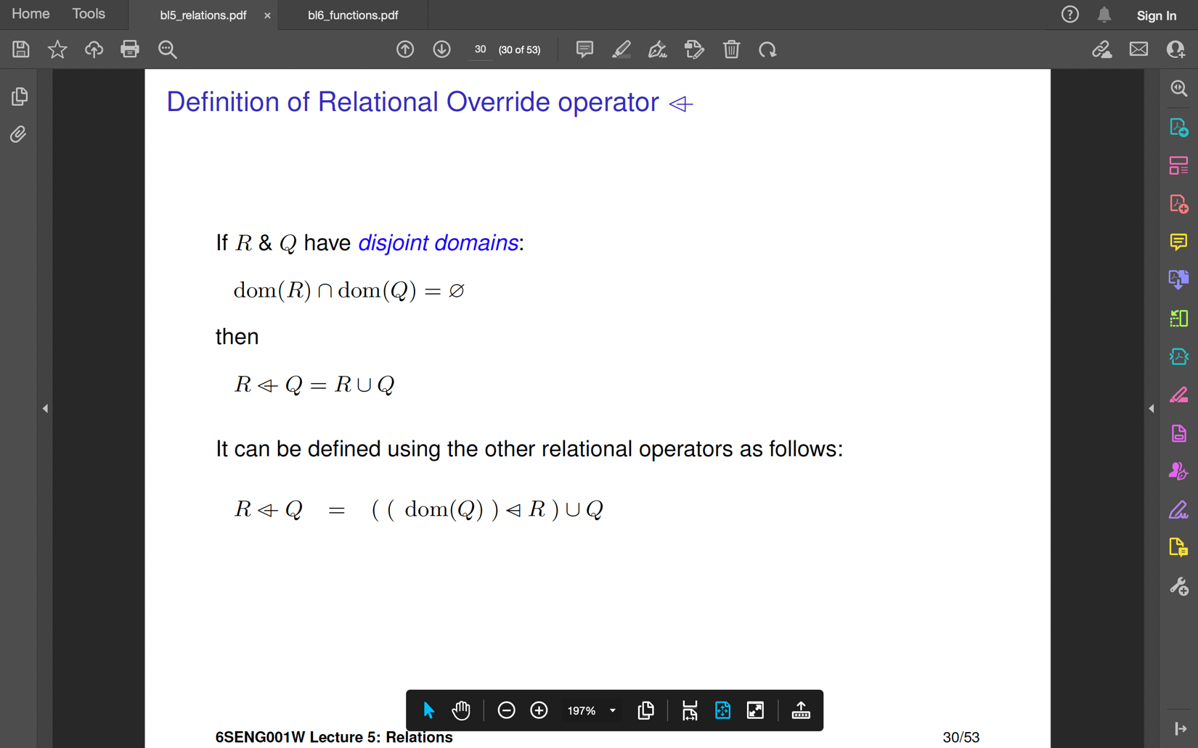

R overridden by the relation Q

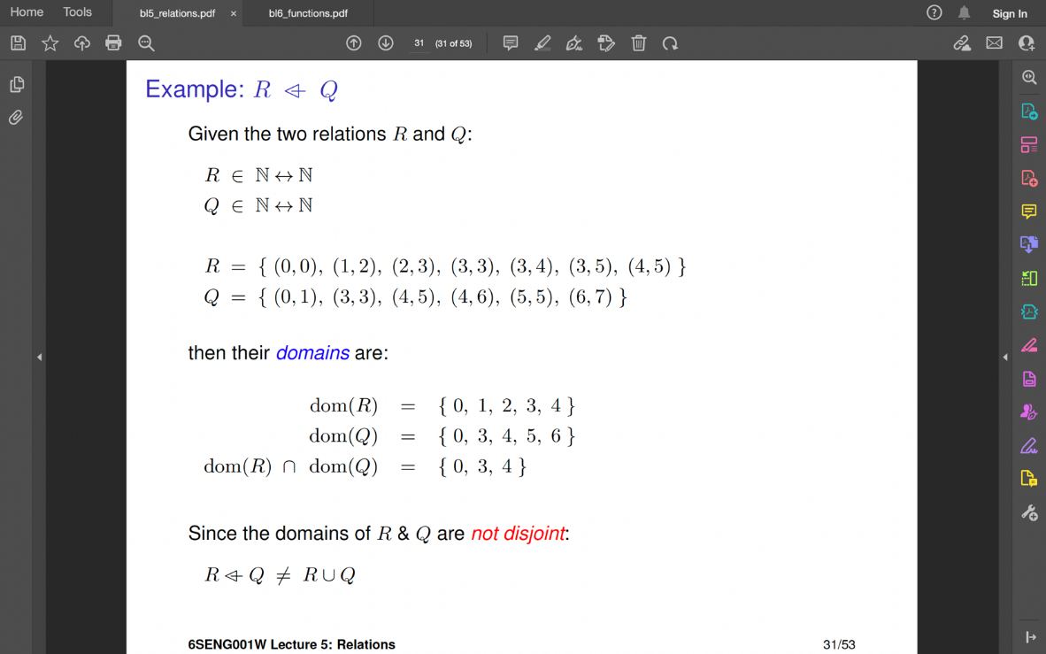

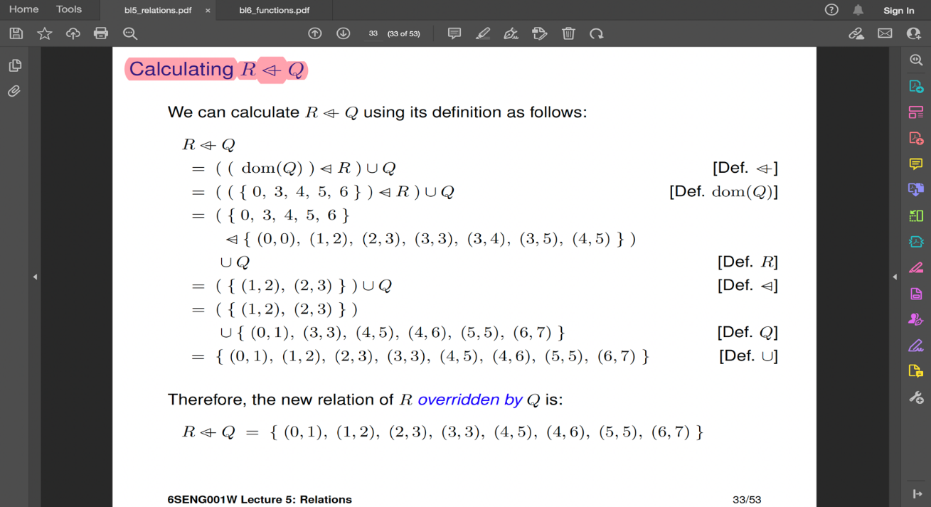

**Identity Relation** 🡪 is a relation which maps all the elements of X to themselves.

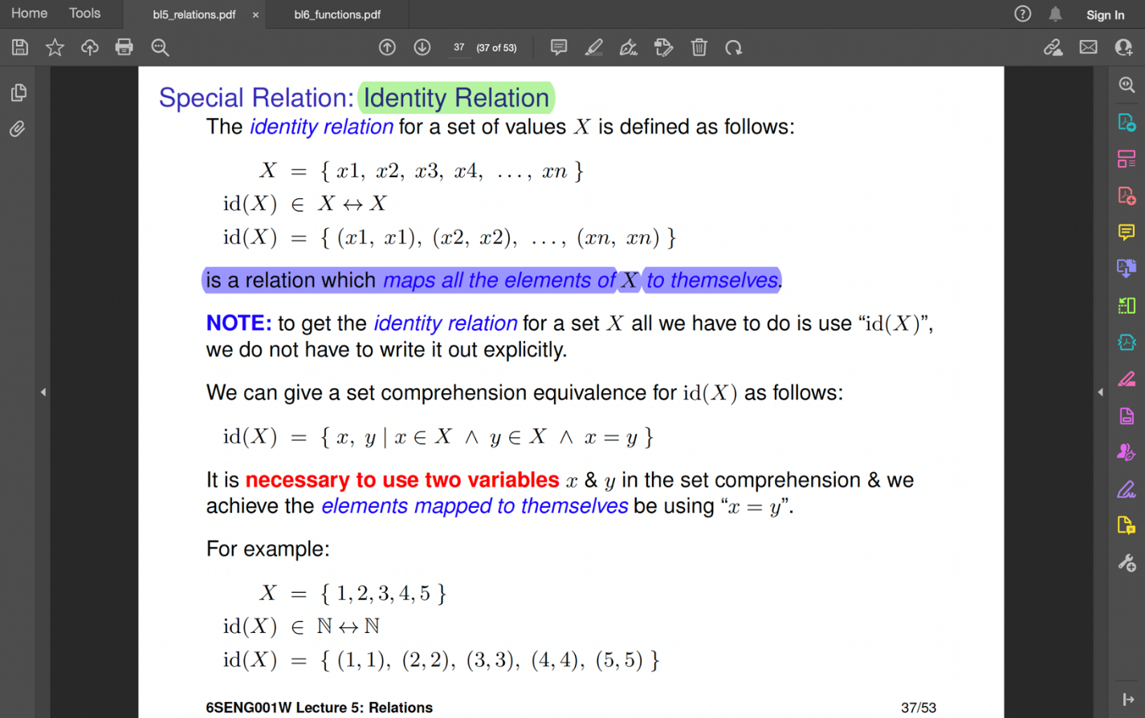

**Inverse Relation**🡪

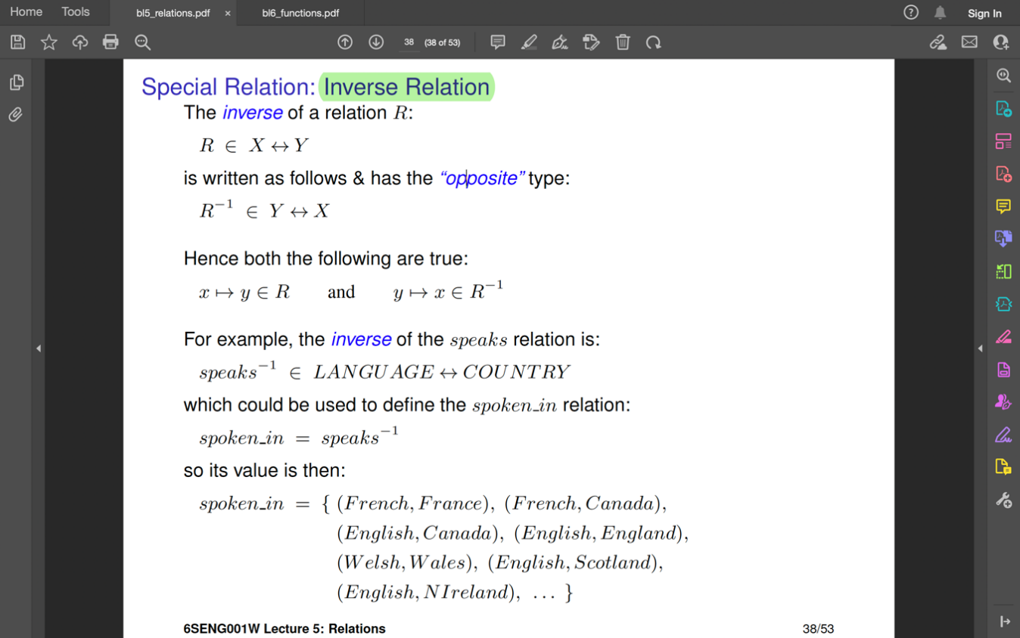

**Compositions of Relation** 🡪 Relations can be joined together by an operation called composition.

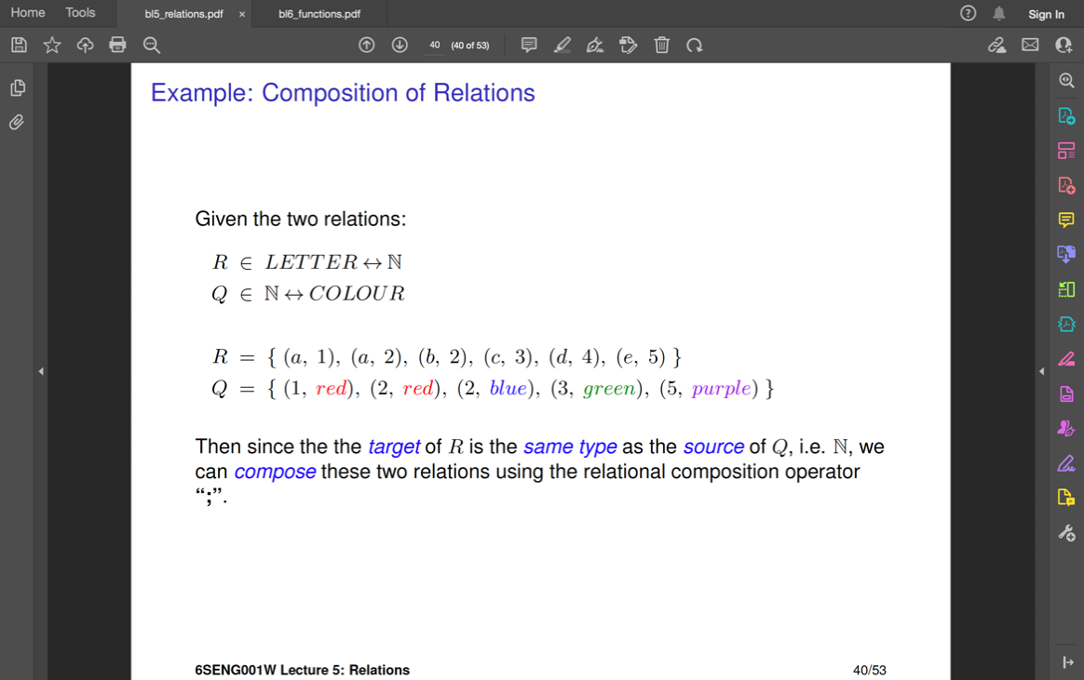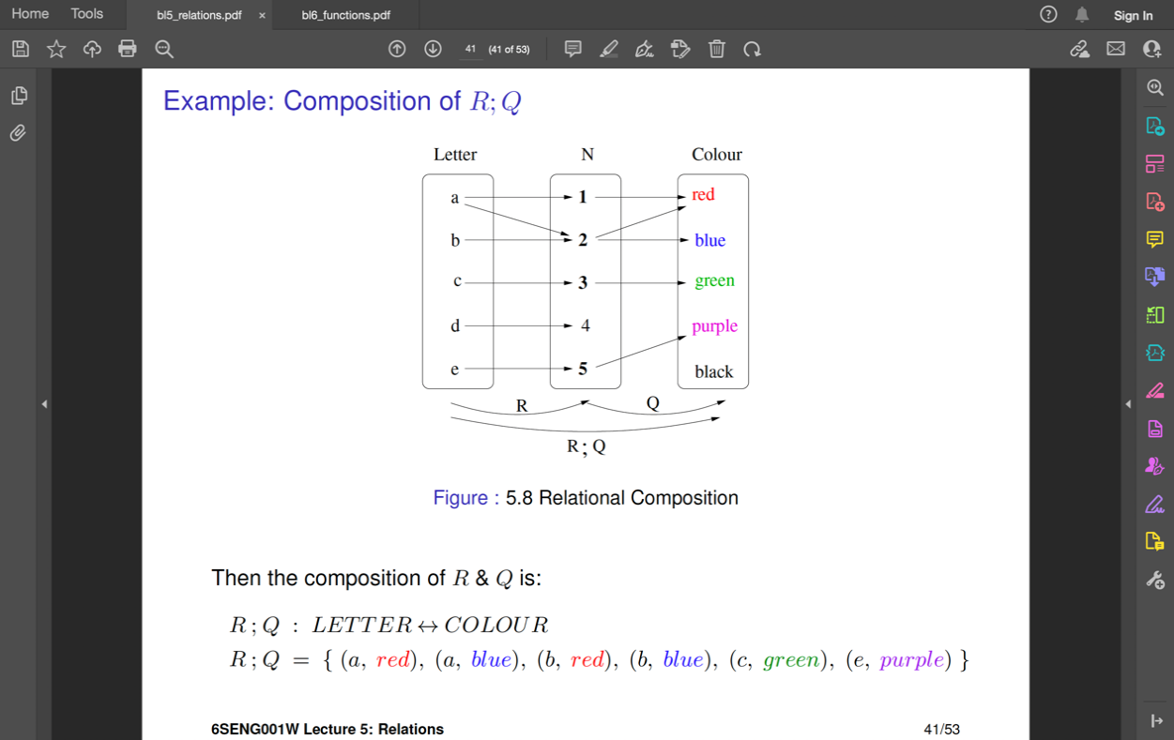

Transitive🡪

Reflexive -Transitive 🡪

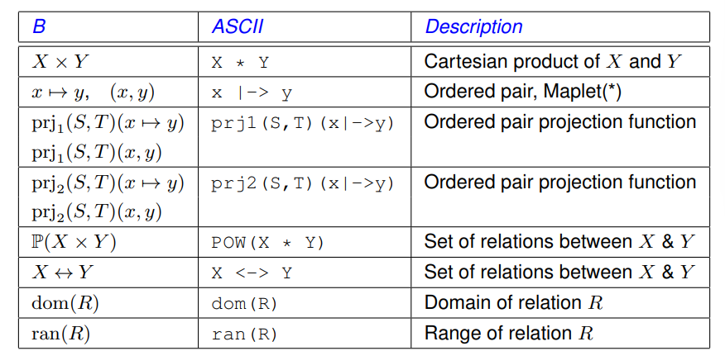

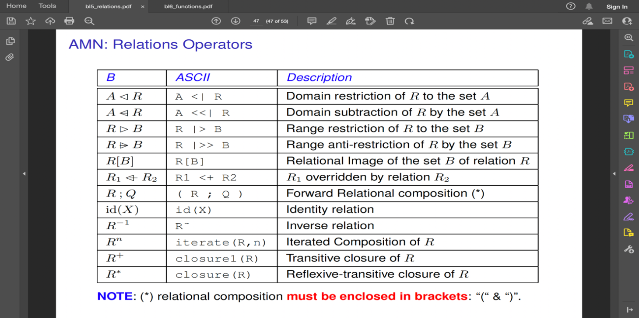

# Week 7

## Functions

Function 🡺 way of specifying some processing which produces a value as a result

Function either provides – a result value or an augmented value

### B functions

* special relation
* is a set of maples/ordered pairs
* function *f* mapping from *x* to *y* is a simple set of (x,y) or

Functions

* many-to-many 🡺 is only a relation, so not a function
* 1-to-many 🡺 is only a relation, so not a function
* many-to-1 🡺 is a function
* 1-to-1 🡺 is a function

Valid function🡺 many values in the domain of the function *dom(f)* to be all mapped onto the same values of the range of the function *ran(f)*

If y!= z, the property of a functionality rules out as it is a 1-to-many relation.

|  |  |
| --- | --- |
| **Relation** | **Function** |
| * not a function, as the value 3 in the domain is mapped to more than one value | * is a function as no value in the domain is mapped to more than one value |

### Function application

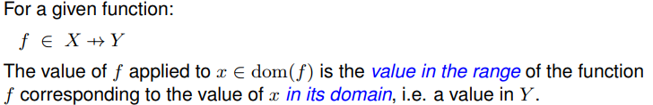

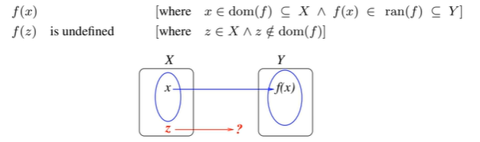

The function is only meaningful for the values of  *x* in the *dom(f)*

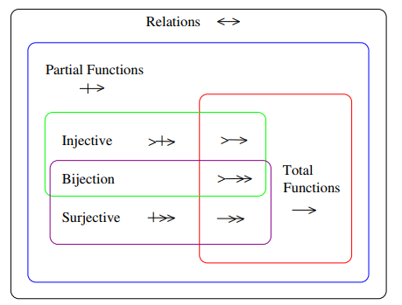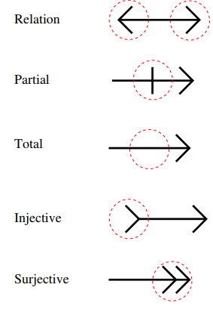

#### Partial Functions

* Some source values are not in the domain of the function.

i.e., for *dom(f) is a subset of X (not equal to X)*

* Partial functions can be defined formally as relations that satisfy the properties of a function

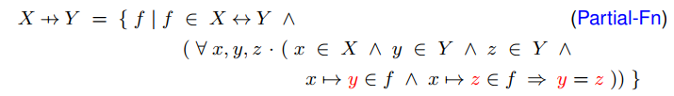

*if ***f*** is a function, the ***x*** element cannot be related to 2 different range elements; therefore, ***y must equal z***

#### Total Functions

* There is value for every possible *x* in the source set ***X***, so ***f(x)*** is always defined
* dom(f) = source set (X)
* every element of the source set ***(X)*** can find an element from Y

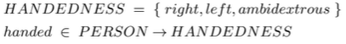

#### Injective Functions (one-to-one function)

* Different values of the source are mapped to different values of the target
* Each value of ***dom(f)*** is mapped to a different value in its ***ran(f)***
* Can be total-injective or partial-injective
* Inverse of an injective function ***f -1***is also an injective function

#### Surjective Functions (on-to functions)

* 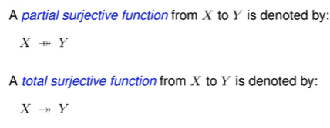A value in the range for every value of the target



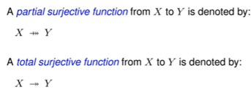

#### Bijective Function (one-to-one relationship)

* 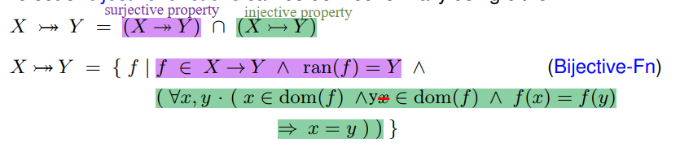Satisfy all the properties of Injective, surjective and the total functions

## Relational Override with functions

Function modification by adding mapping pairs, or removing teams, or changing the mapping between values.

* Function ***f***overridden by function ***g***: 

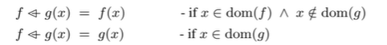

* When function ***f*** is overridden by function ***g***, and the domains are disjoint:



If both ***f*** and ***g*** are functions, the result is a function

If one of them is a relation, the relation is highly likely a relation

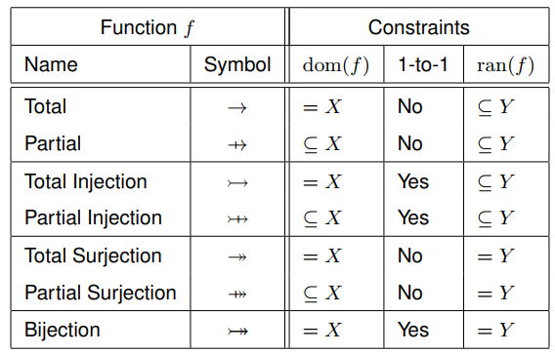

## AMN: Functions

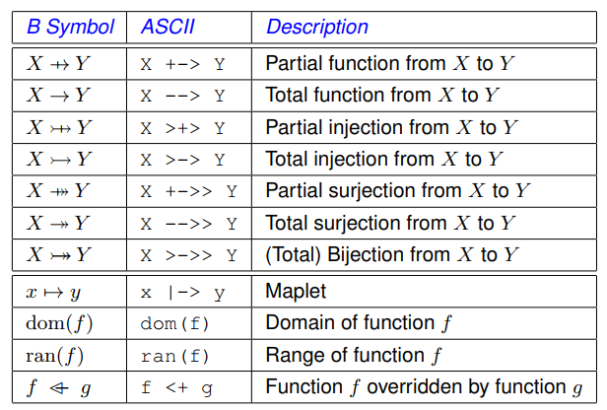

# Week 8

## Sequences

* 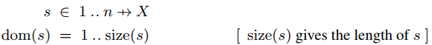Needed for:
  + Distinguish values of a set by position
  + Permit duplicates
  + Impose order of values
* Sequence is a constant can be defined by listing elements in order.
* Empty sequence 🡪 [ ]
* Sequence definition 🡪

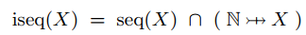

* Injective sequence 🡪
* Concatenation 🡪 join sequences (total function)

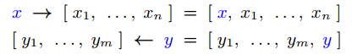

* Front & End insertion 🡪 (total function)

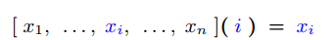

* Selection 🡪



* First 🡪 (partial function)



* Tail 🡪 (partial function)



* Last 🡪 (partial function)



* Front 🡪

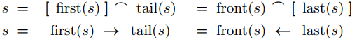

* Relationships between operators 🡪
* Front sub sequence 🡪 select the first *n* elements of the sequence
* Tail sub sequence 🡪 remove the first n elements of the sequence



* Reversal 🡪 (total function)
* Relational Domain Restriction 🡪

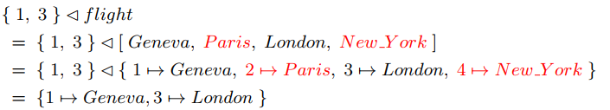

* 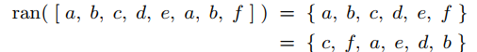Relational Range Restriction 🡪